**10. Write a C program to implement Linked list operations**

**PROGRAM:**

#include <stdio.h>

#include <stdlib.h>

struct Node {

int data;

struct Node* next;

};

void insertAtBeginning(struct Node** head_ref, int new_data) {

struct Node* new_node = (struct Node*)malloc(sizeof(struct Node));

new_node->data = new_data;

new_node->next = (*head_ref);

(*head_ref) = new_node;

}

void displayList(struct Node* node) {

while (node != NULL) {

printf("%d -> ", node->data);

node = node->next;

}

printf("NULL\n");

}

int main() {

struct Node* head = NULL;

insertAtBeginning(&head, 3);

insertAtBeginning(&head, 7);

insertAtBeginning(&head, 9);

printf("Linked list: ");

displayList(head);

return 0;

}

**INPUT:**

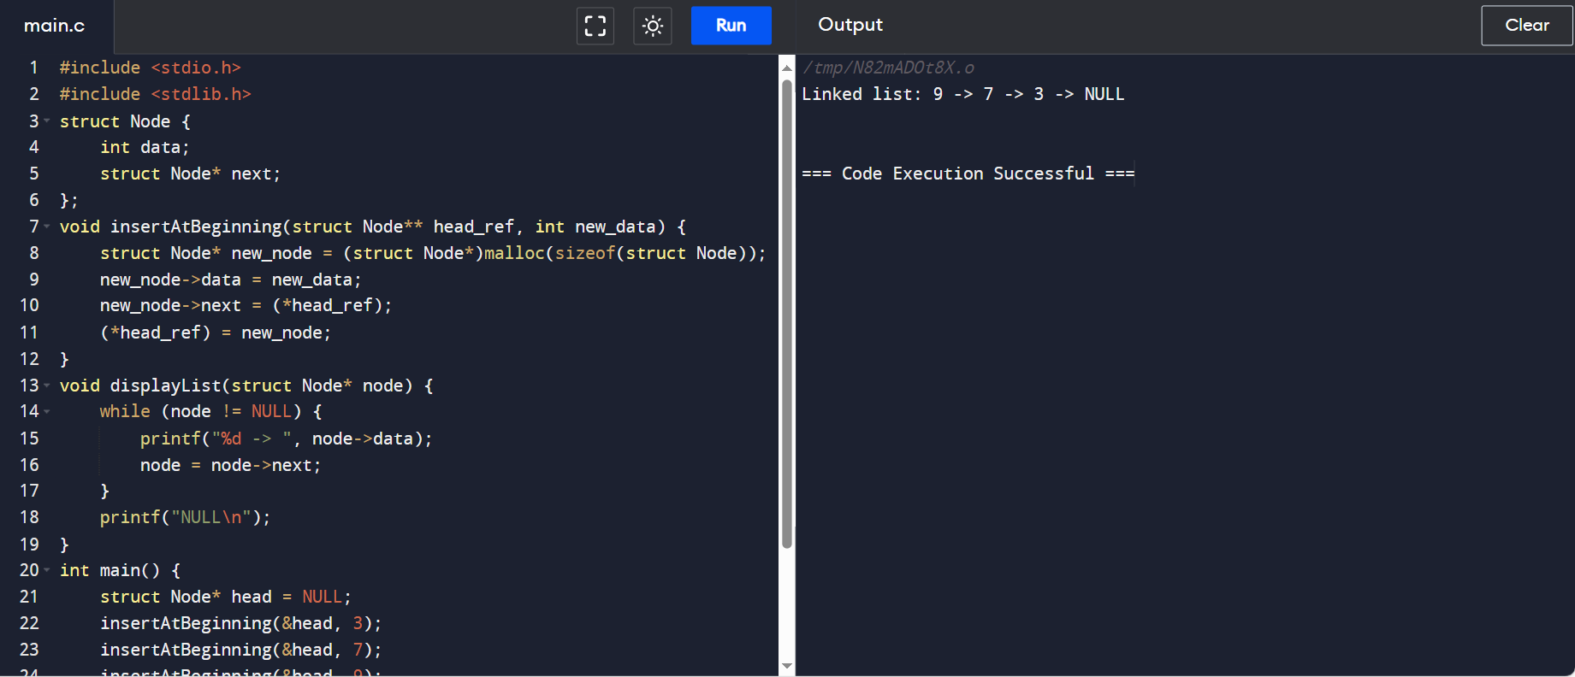

**OUTPUT:**

